***INTERNAL CRISIS – 3D Educational Platform Medical***

***Action – Adventure Mobile Game***

***------------------------------------------------------------------------***

A Capstone Project Presented to the Faculty of

College of Information, Computer and Communications Technology

University of San Jose - Recoletos

Cebu City, Philippines

***------------------------------------------------------------------------***

*In Partial Fulfillment*

*Of the Requirements for the Degree of*

*Bachelor of Science in Information Technology*

***------------------------------------------------------------------------***

*By*

***LLENARES, Levi M.***

***GARCIA, Ivan Dave T.***

***BODIONGAN, Stanly A.***

***MR. VICENTE PATALITA***

***Adviser***

**CHAPTER 1**

**INTRODUCTION**

**RATIONALE OF THE STUDY**

In this generation, the most played genre of a video game is “action-adventure game “. Action-adventure game is a hybrid genre, a mixed element from an action game and an adventure game, especially crucial elements like puzzles it requires many physical skills, but also offer a storyline, numerous characters, an inventory system, dialogue. This kind of games normally include a combination of complex story elements, which are displayed for players using audio and video. The story is heavily reliant upon the player character’s movement, which triggers story events and thus affects the flow of the game. Some examples of action-adventure games include The Legend of Zelda [14], God of War [15], and Tomb Raider series [16].

Medical games. In most of the games of this genre, the main goal is similar: to treat and cure the patient as possible, whether it’s cancer or something much more devastating. The most common medical games are surgery simulators, and the environment is inside of the hospital. Also, medical games can give you some knowledge about medicals and give awareness and prevention to the users. Medical-based games are quickly becoming favorites by medical students as the practicing of their field while enjoying. Some examples of medical games include Amateur Surgeon [17], Two Point Hospital [18] and Lifesigns: Surgical Unit [19].

Internal Crisis is an action-adventure game that mixed-up by a medical game genre. Therefore, you can experience action and adventure feelings while you’re gaining some knowledge. There’s a medical drug that has been invented by a mad scientist and that’s the character. The character can explore to your organ, fight with the cancer cells, viruses, bacteria, help an infected cell, clean or regenerate a damaged part of the organ, and can fight alongside with the fighter and support cell. This game has a mission or a task to unlock new stages and weapons. Also, the character will give tips to users about awareness and prevention.

**REVIEW OF RELATED LITERATURE**

**HEART**

**What is heart** the human heart is an organ that pumps blood throughout the body via the circulatory system, supplying oxygen and nutrients to the tissues and removing carbon dioxide and other wastes.

**Myocardial ischemia** occurs when blood flow to your heart is reduced, preventing the heart muscle from receiving enough oxygen. The reduced blood flow is usually the result of a partial or complete blockage of your heart's arteries (coronary arteries). Myocardial ischemia, also called cardiac ischemia, reduces the heart muscle's ability to pump blood. A sudden, severe blockage of one of the heart's artery can lead to a heart attack. Myocardial ischemia might also cause serious abnormal heart rhythms.

**KIDNEY**

**What is kidney** The [kidneys](https://www.webmd.com/urinary-incontinence-oab/picture-of-the-kidneys) are a pair of bean-shaped organs on either side of your [spine](https://www.webmd.com/back-pain/discs-of-the-spine), below your ribs and behind your belly. Each kidney is about 4 or 5 inches long, roughly the size of a large fist.

The kidneys' job is to filter your [blood](https://www.webmd.com/heart/anatomy-picture-of-blood). They remove wastes, control the body's fluid balance, and keep the right levels of [electrolytes](https://www.webmd.com/drugs/drug-3399-oral+electrolytes+oral.aspx). All of the blood in your body passes through them several times a day.  
 **Kidney stones** (renal lithiasis, nephrolithiasis) are hard deposits made of minerals and salts that form inside your kidneys. Kidney stones have many causes and can affect any part of your urinary tract — from your kidneys to your bladder. Often, stones form when the urine becomes concentrated, allowing minerals to crystallize and stick together. Passing kidney stones can be quite painful, but the stones usually cause no permanent damage if they're recognized in a timely fashion. Depending on your situation, you may need nothing more than to take pain medication and drink lots of water to pass a kidney stone. In other instances — for example, if stones become lodged in the urinary tract, are associated with a urinary infection or cause complications — surgery may be needed.

**LUNGS**

**What is lungs**: The lungs are a pair of spongy, air-filled organs located on either side of the chest. The [trachea](https://www.webmd.com/lung/picture-of-the-trachea) conducts inhaled air into the lungs through its tubular branches, called bronchi. The bronchi then divide into smaller and smaller branches, finally becoming microscopic.  
 **Emphysema** is a lung condition that causes shortness of breath. In people with emphysema, the air sacs in the lungs (alveoli) are damaged. Over time, the inner walls of the air sacs weaken and rupture — creating larger air spaces instead of many small ones. This reduces the surface area of the lungs and, in turn, the amount of oxygen that reaches your bloodstream. When you exhale, the damaged alveoli don't work properly and old air becomes trapped, leaving no room for fresh, oxygen-rich air to enter.

**BRAIN**

**What is brain:** The human brain is the central organ of the human nervous system, and with the spinal cord makes up the central nervous system. The brain consists of the cerebrum, the brainstem and the cerebellum It controls most of the activities of the body, processing, integrating, and coordinating the information it receives from the sense organs, and making decisions as to the instructions sent to the rest of the body. **Meningococcemia** can affect your blood’s ability to [clot](https://www.healthline.com/health/symptoms-and-complications-blood-clots), resulting in bleeding disorders. It can also sometimes occur with meningitis. [Complications associated with meningitis](https://www.healthline.com/health/meningitis-awareness/complications-and-risks) include [hearing loss](https://www.healthline.com/symptom/hearing-loss), brain damage, and [gangrene](https://www.healthline.com/health/gangrene). In some cases, meningitis can be fatal.

**Liver**

**What is liver:** The liver is a large, meaty organ that sits on the right side of the belly. Weighing about 3 pounds, the liver is reddish-brown in color and feels rubbery to the touch. Normally you can't feel the liver, because it's protected by the rib cage.

**Cirrhosis:** is a late stage of scarring (fibrosis) of the liver caused by many forms of liver diseases and conditions, such as hepatitis and chronic alcoholism Each time your liver is injured — whether by disease, excessive alcohol consumption or another cause — it tries to repair itself. In the process, scar tissue forms. As cirrhosis progresses, more and more scar tissue forms, making it difficult for the liver to function (decompensated cirrhosis). Advanced cirrhosis is life-threatening.

The liver damage done by cirrhosis generally can't be undone. But if liver cirrhosis is diagnosed early and the cause is treated, further damage can be limited and, rarely, reversed.

**REVIEW OF RELATED WORKS**

**Ozzy & Drix**

The Gameplay is a 3D side-scroller which you take control as Ozzy & Drix you play Drix only for the first level and Ozzy for the rest of the game. The Main of objective for most of the levels is to run and shoot enemies as you go and collect keys to progress to other parts of the level. There are other two types of gameplay in the game such as Rail shooting, Driving Stages. [25]

**Defend Your Life: TD**

tower defense set in human body where players are fighting against villain hordes of viruses and bacteria. Levels and units correspond to reality of human anatomy. You take the role of commander of human body’s sentinels. Your objective is clear – bacteria and viruses shall not pass through defense system. Way how to deal with enemy hordes is simple. Think tactically, construct and upgrade buildings, reinforce your troops, support them with special upgrades, annihilate the enemy with mighty powers. [24]

**Project Objective**

This study is a 3d hack and slash game with a 3D platform environment that gives the player a piece of knowledge about the disease how to prevent and to know the causes of it and help them educate while playing.

Specifically, the developers aim to:

* To Use Maya in 3D modeling.
* Use Mixamo as animator.
* Use Unity in creating and animation of the game.
* Use Visual Studio for the Code Script.
* To Use Photoshop for the UI

**Scope and limitations**

The focus of the study is about organs that have diseases which compose of lungs, kidneys, heart, liver and brain which the main character will exterminate the bad cells that cause the diseases and clean the environment of the organs.

The stages of the game represent of the organs, the stages are Lungs: 2 levels and the disease is Emphysema, Heart: 4 levels and the disease is Myocardial Ischemia, Kidney: 2 levels and the disease is Kidney Stone, Liver: 1 level and the disease is Cirrhosis and the last organ is Brain: 2 level and the disease is Meningococcemia. The game has time limit, if the player can’t handle the time, the owner of the body will die. Every organ has a shop that will sell weapons and recommend of what is the best weapon to kill those monster that stayed on the organ.

A doctor will be prompted and will guide the player throughout the game, and will also grant tips for the player about diseases, symptoms, and causes.

The player will control the character by using the joystick screen to attack respectively. The game only supports a Mobile.

**CHAPTER II**

**DESIGN SPECIFICATION**

This chapter will discuss about the game description, gameplay, game flow, game elements, game physics, artificial intelligence, user interface, target market, terrain, icon, character, enemies, and story of the game.

**GAME DESCRIPTION**

The Internal Crisis is a 3D Educational Platform Action-Adventure Mobile Game where the game is based on the human internal organ in which the character will exterminate all the bad cells and help regenerate the organ.

**DESIGN GOALS**

The game aims to achieve the following goals:

1. Develop a fun and educational gameplay.
2. Discovery – players discover the storyline, every organ.
3. Explore – player can explore freely around the organs of the human body.
4. Power – the game is about fighting bad cells and defeat bosses to regenerate the human body.
5. Have art and design that is somewhat similar to the internal organs in which the game takes place.
6. Establish the Internal Crisis on Internal Organs that would help the user visualize the events inside.

**INFLUENCES AND SOURCES**

We have researched internal organs in which this game takes place in order to get an idea to give the right look and feel on the game, and to develop ideas for the game environment.

We have reviewed several 3D platform action-adventure game genres: Ozzy and Drix. And looked on pc games, apps, and websites that have some relation to our game development.

***Target Market***

Our ideal user has the following characteristics:

1. Male or Female
2. 8 years old and above
3. Medical Students
4. The interest of the medical and action-adventure game
5. Has a Mobile phone or tablet
6. Purchases content through apps, or online

Although the Medicals Student is the primary target user because they can relate and apply to the game easier than others. The secondary target is the other people who aged of 8y/o above because, this not only for educational only but, also for having an experience of fun and adventure.

**Functional Specifications**

***Game mechanics***

***Core Game Play***

The playable character moves in a 3D platform, exploring around organs levels that extend from the x, y, and z axis of the screen. Enemies will appear in the random part of the organ as the character try to finish the task, the player must defeat them to decrease the death rate of the human. The play can also have an ally to deploy to fight alongside the player. The player may also encounter an obstacle that can be solved using a weapon or dodging it.

As the player can complete the quest, the player can receive achievements and rewards, which can be retrieved in the achievement menu tab. The player can also be rewarded how fast the task or mission finished by a hundred percent reward and has a chance of big rewards will be received which the player allowed to level-up the weapon and the buffs.

The character will give you tips about how the organs turn like that, and how to avoid this disease. The game has cut scenes that are displayed after the player defeated the boss in every stage. Also, the character may face a different boss in every stage of every organ.

***Game Flow***

Actions that the Playable Character can perform are:

1. Move around (x,y and z axis).
2. Jump while moving around (x,y and z axis)..
3. Jump while attacking.
4. Attack combo, every combo the damage increases by one.
5. Perform a special skill.
6. Perform different attacks in different weapons (injection, scissors, and vacuum bag).
7. Destroy or pass an obstacle.
8. Perform healing others.

***Character/Units***

1. Tanlyoxic – A medical drug that has been invented by a mad scientist that can attack any bad cells around the organ, can regenerate the part of the damaged organ and can help an infected cell. Need to dodge the attack of the bad cells to maintain the effects and damage of the weapon and health. To back the damage player, need to defeat 3 enemies.
2. White Blood (plasma) – They are the cells who will fight alongside with the playable character, they will help the playable character to defeat the bad cells. They have average damage and high health.
3. Platelets – They are support cells, they can’t attack any enemies, but they can support the character by healing and give some plus damage. They have no damage but they have average health.
4. Viruses – They have an aggressive move, they can attack and infect the other cells. They have average health and damage.
5. Cancer cell – They are the ones who can give damage through the area, long-range, and low damage with high health and they will multiply after defeating by the character. Also, they will convert the infected cells into a virus.
6. Germs – They are the one who gives dirt of the area of the organ, they have very low damage and have average health.
7. Boss – They have high damage and high health. They are the last ones to defeat in every stage, they can cast special skills to depend on what kind of the stage (disease).

***Game Play Elements***

These are elements present in the game level that the Mobile can interact with:

• Health recovery: Buff or an ally that recovers the player’s health bar.

• Weapon Power recovery: through Ally or actions that fill the player’s weapon power bar.

• Destructible obstacles: Obstacles that hinder the player’s progress and must be attacked until destroyed.

• Platform obstacles: Obstacles that hinder the player’s progress and can be surpassed by jumping over them.

Additionally, we have elements that communicate the PC’s game state:

• Health bar: Bar that represents the Character health, which has a fixed health bar.

• Power bar: Represents the Character Bar to enable performs a special skill.

• Power Weapon bar: Bar that represents the Character weapon. It has a high bar; the more damage can be.

• Tips Scene: These will be presenting tips from the Character that give some facts to the users about the game and medical staff.

There also exist elements that determine the Character’s stats:

• Level up the weapon: This shows the progress that a character has made, as he gains a level of the weapon once he completes the task or mission, and for every level, the character weapon will gain more damage of the weapon.

• Attack attribute: This attribute determines the damage caused by the Character attack. The damage improves by leveling up the character weapon.

• Power attribute: This attribute determines the damage caused by the Character Special attack. The damage improves by leveling up the character weapon.

**ARTIFICIAL INTELLIGENCE**

**Regular minions:**

* Enemies appear on any angle of the screen.
* Some enemies will be located in a specific position on levels in stages.
* Enemies will pursue the Character if the character is in the near distance the monster. The monster attacks will vary but could attack repeatedly.
* Enemies don’t respawn when killed by the user.

**Boss:**

* The Boss can roam around the specific organ.
* The Boss on each stage has different special attacks.
* Boss uses its special attack when their HP at 75, 50, 25%.
* Boss Special attacks have time casting and it is the most vulnerable time that weakens the boss.
* Boss can summoned a minions.

**USER INTERFACE**

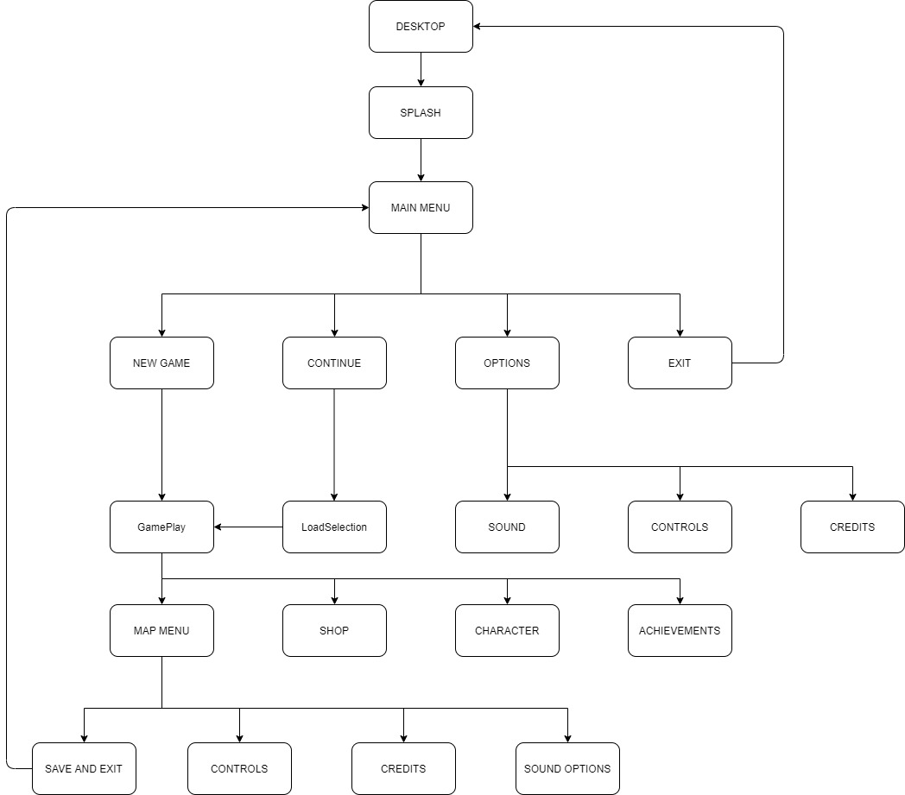

**FUNCTIONAL REQUIREMENTS**

Splash: This is the initial screen and introduces the logo.

Main Menu: Presents all of the possible choices for the user as well as a graphic image that introduces the look of the game.

Continue: Displays all of the user game data and give the option to continue where the user's last progress.

Options: Gives the user the ability to control some of the game’s attributes, such as sound volume and controls.

Exit: Closes the game and directs the user to the desktop.

Game Menu: Can be accessed during gameplay and works as a sort of pause menu, from this page the user can change the sound volume, controls, and also save and quit the game.

Gameplay: Where the game happens, contains a character portrait, coins, a health and a power bar.

Character: where the user can see the character info, inventory, monster info’s.

Shop: The user can buy buffs.

Achievements: Where the user can check all the possible achievements throughout the game as well as the one that is yet to be unlocked.

Credits: Where the details about the Developers / Team.

**MOCKUPS**

**Internal Crisis**

1. Main Menu

Figure : Splash Image

New Game

Continue

Options

Exit

Graphic

Graphic

Figure : Main Menu

Game Data 1

Game Data 1

Game Data 1

Game Data 1

BACK LOAD

Figure : Load Selection

Sound Options

Controls

Credits

Back

Figure : Options

LLENARES, LEVI

GARCIA, IVAN DAVE

BODIONGAN, STANLY

Figure : Credits

Master Volume Enable

Music

SFX

Speech

BACK

Figure : Sound Option

JUMP MAP

LEFT INVENTORY

RIGHT QUEST

DUCK SWAP WEAPON

ATTACK/HEAL

BACK

Figure : Controls

Skill bar

Option

Health bar

Shop

Ach.

Character portrait

Figure : Game Screen

Sound Options

Controls

Credits

Save and Exit

BACK

Figure : Game Menu

IMG

IMG

Inventory

Shop

Figure : Bag Menu

IMG

TXT

Mission & Task

Finished mission & task

Queue

Figure : Quest and Achievements

**GUI OBJECTS**

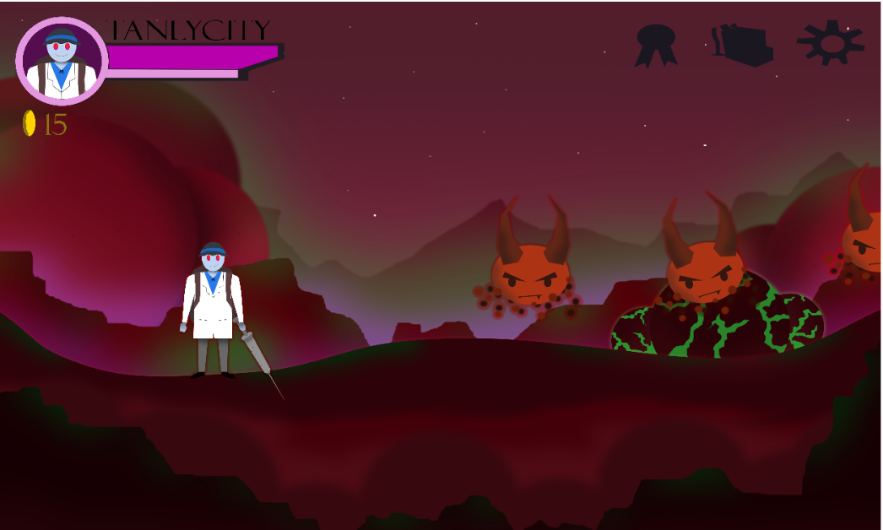The GUI of the game is divided in a few sections. First, we have the HUD (Heads Up Display). This is the information that appears on screen when the user is actually playing the game, the HUD contains:

* Character Image – Displays the character.
* Enemy Image – Displays the Enemy.
* Health bar – Represents the current health of the character.
* Skill bar - Represents the current skill points of the character, which the character can use skill when have enough points.
* Shop – Display the shop where the user buys.
* Achievements – Display the achievements user achieved and unlocked achievements.
* Settings – Where the user finds the options, controls, credits, and save and exit.

There are other GUI objects located in the menus and are comprised of different buttons to navigate through the screens, in order to interact with them the user must simply press the key that has been chosen in controls.

**ART AND VIDEO**

**Overall Goals**

The team have sought to achieve and art style of a cartoony and chibi. Our style is slightly darker yet it maintains a cartoony mode. We used original artwork in the game interface in order to create a unique outlook. By using new background art and 3D pose-able models for the characters we intended to achieve an art style but still provided a fresh and unique experience for the player.

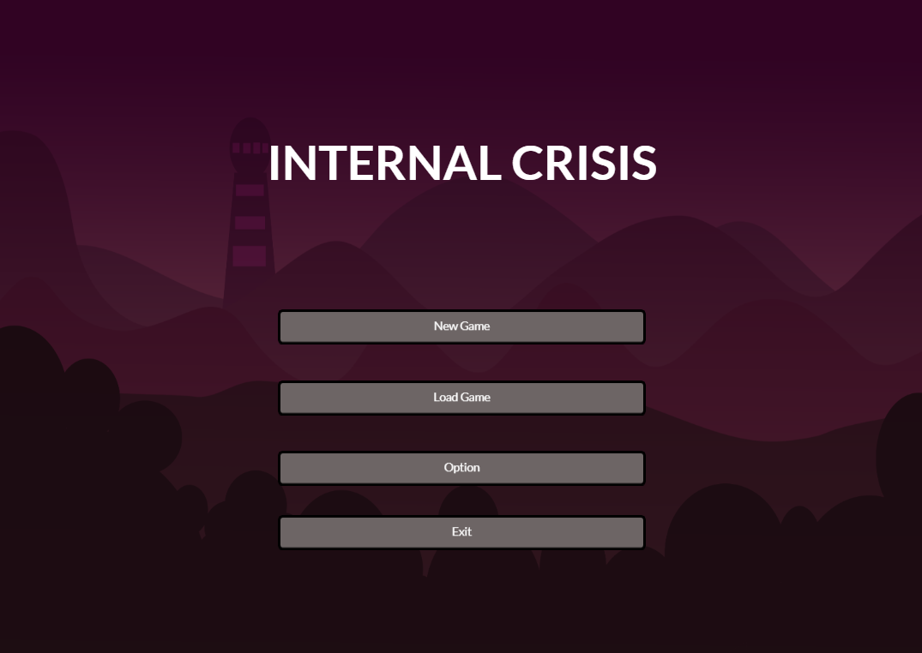

Main Menu

**GUI**



Character Health and Power bar.

* Character Portrait;
* Health bar;
* Power bar;
* Coins;
* Game Menu;
* Inventory;
* Achievements;

**Marketing and Packaging Art**



Splash image



PC Icon

The packaging art for our game consists of PC Icon, and the very first image when one opens the game (splash screen) has the Internal Crisis on it.

* Splash Screen;
* PC Icon

**Terrain**

This is the background for our game, that will represent for the organs of the body.



Background art for lungs



Background art for kidney

**GAMEPLAY ELEMENTS**

* Health recovery buff;
* Power recovery buff;

**Story**

A poor person that cannot afford to go to the hospital to get treated because of financial problem that’s why he goes to the mad scientist to be treated hoping that he will be cure though there is still a big possibility that he will die in the process and have an agreement if he will be cure he will be the assistant of the mad scientist.

**Player Character**

Tanlyoxic: is unique antibiotic that is created by the mad scientist in order to cure the disease.

**Ally Characters**

White Blood (Plasma): will fight alongside with that playable character.

Platelet: supports the character through healing.

**Enemy Characters**

Virus:  
Cancer Cells:

Bacteria:

Mini Boss:

2nd Hand Boss:

Boss:

**Story theme**

Cure the disease in particular organ to finish the stage and proceed to another organ.

**Visual theme**

Organs that have a disease and needed to be cure in order to survive.

**Stage Requirements**

***Level Diagram***

|  |  |  |  |  |  |
| --- | --- | --- | --- | --- | --- |
| **Organ** | **Disease** | **Level 1** | **Level 2** | **Level 3** | **Level 4** |
| Lungs | Emphysema | Enemies, 2nd hand of Boss and Boss Battle | Enemies, 2nd hand of Boss and Boss Battle  Same Large numbers of monster but has higher dmg than first level | None | None |
| Heart | Myocardial Ischemia | Enemies, 2nd hand of Boss and Boss Battle | Enemies, 2nd hand of Boss and Boss Battle  Same Large numbers of monster but has higher dmg than first level | Enemies, 2nd hand of Boss and Boss Battle  Same Large numbers of monster but has higher dmg than first, and second level | Enemies, 2nd hand of Boss and Boss Battle  Same Large numbers of monster but has higher dmg than first, second, and third level |
| Kidney | Kidney Stone | Enemies, 2nd hand of Boss and Boss Battle | Enemies, 2nd hand of Boss and Boss Battle  Same Large numbers of monster but has higher dmg than first level | None | None |
| Liver | Cirrhosis | Enemies, 2nd hand of Boss and Boss Battle | None | None | None |
| Brain | Meningococcemia | Enemies, 2nd hand of Boss and Boss Battle | Enemies, 2nd hand of Boss and Boss Battle  Same Large numbers of monster but has higher dmg than first level | None | None |

**Asset Revelation Schedule**

The game has two different kinds of items, the Health Recovery Item, that recovers the player’s health, and the Power Recovery Item that fills the player’s power bar.

|  |  |  |
| --- | --- | --- |
| ITEM | ALLY BUFF | RECOVER |
| HEALTH RECOVERY | 10% chance of drop | 25% of total |
| POWER RECOVERY | 10% chance of drop | 25% of total |

**Stage Design Seeds**

Lungs with 2 different levels, every level has a boss and their ability will depend of the disease. In every level the character will give a tip in the users about facts of medicals, and disease.

Kidney with 2 different levels, this stage is similar for the Lungs mechanics but with different stats and appearance of the monster, also has an obstacle.

Heart with 4 different levels, the environment of the heart is thin, that has a chance the character has a chance that will be crashed by the thin tube of the heart.

Liver with 1 level only, but the liver has the biggest environment among the other.

Brain with 2 different levels, in the left and right side of the brain, the environment is more on tubes that covered of liquid that can cause of the disease.

**CHAPTER III**

**SOFTWARE DEVELOPMENT AND TESTING**

To successfully develop a game everything must undergo a process, have an effective working environment and helpful tools to be used. In this chapter, the researchers will discuss the processes that help shape the project, the working environment that the researchers chose and the tools that the researchers use to help develop this project.

**DEVELOPMENT SOFTWARE PLATFORMS, DEVELOPMENT ENVIRONMENTS, AND TOOLS**

INTERNAL CRISIS is developed using Unity 2018.4.17f1 (64-bit) running on Windows 10 64-bit. Unity Engine is a cross-platform gaming engine, which is mainly used to develop video games and as well as simulations for computers, consoles, and mobile devices.

The game’s 3D models are developed, rigged and animated using Autodesk Maya 2019. Maya is a 3D graphics software that runs on Windows, macOS, and Linux operating system that is primarily used to create 3D applications, including video games, animated film, TV series, or visual effects.

The programming language used in the game is C# in which the researchers have studied the language. The Integrated Development Environments

(IDE) used:

* Unity’s Visual Studio – Visual Studio is an Integrated Development Environment (IDE) tool from Microsoft and it is installed by default with Unity. a creative launching pad that you can use to edit, debug, and build code, and then publish an app.

**UNITY PHYSICS ENGINE**

The character will collide on all of the objects in the game. The researchers used Unity's built-in physics engines to make the obstacle. The physics engines are attached to the collider that is added to the game object.

**NAVIGATION MESH**

The navigation mesh is an abstract data that is integrated with a similar use in Unity. This will be used by some of the game’s obstacles to make it follow the player upon entering a certain area of the map.

**UNITY ANIMATION PANE**

**DEVELOPMENT AND TESTING PROCESS**

Internal Crisis is programmed under an object-oriented language called C# for the logical algorithm functionalities. The following are the IPO tables for the scripts that correspond to a certain feature in the game.

**PRODUCTION PROCESS**

**CHARACTER SKETCH**

A sketch served as a guide for the researchers in order to have achieve the correct form of the character when it is modeled in Autodesk Maya 2019.

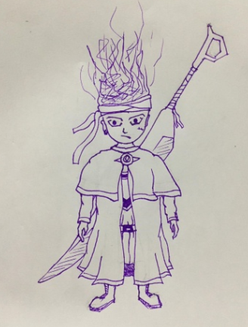

Figure 15: Male character sketch for map.

**CHARACTER CONCEPT**

Internal Crisis have only 1 character that a player can use. A male character, the character will be in low poly looking form. The 3d model of the character is designed in Autodesk Maya 2019 made from the basic shapes such as the cube, sphere, and others. The shapes are modified by the edges, planes, and points to create the desired character design.

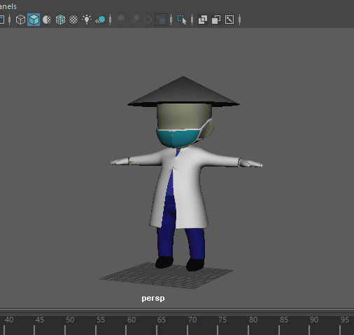

Figure 16: Male character sketch for map.

The character of Internal Crisis is inspired from the medical capsule.

**MODELLING** 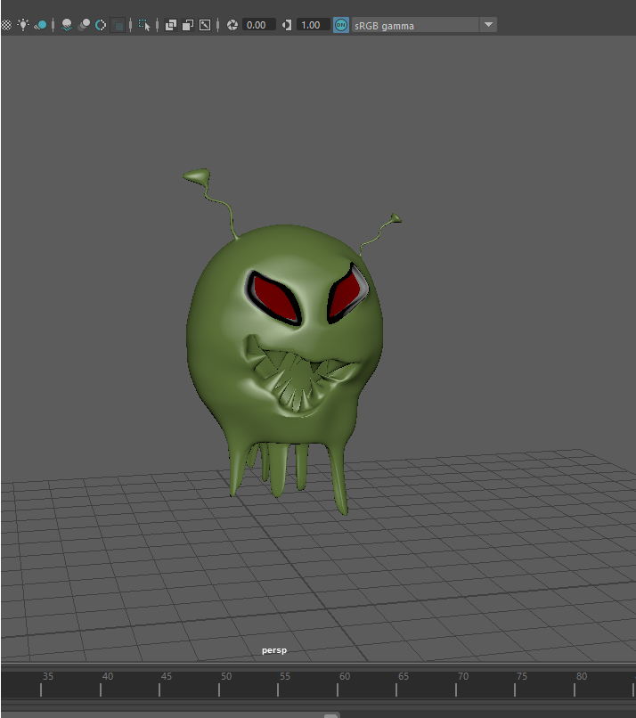

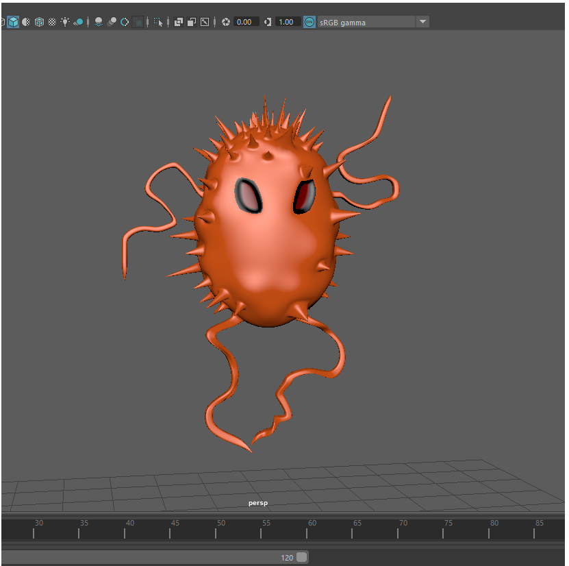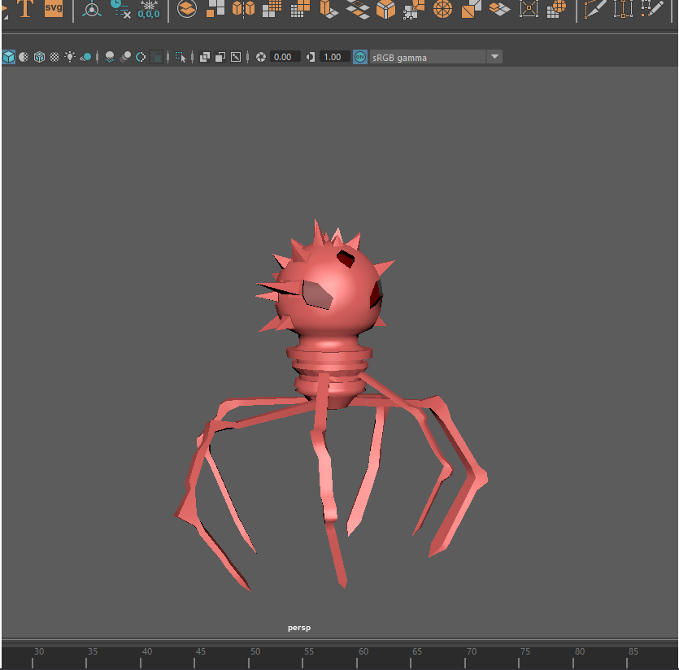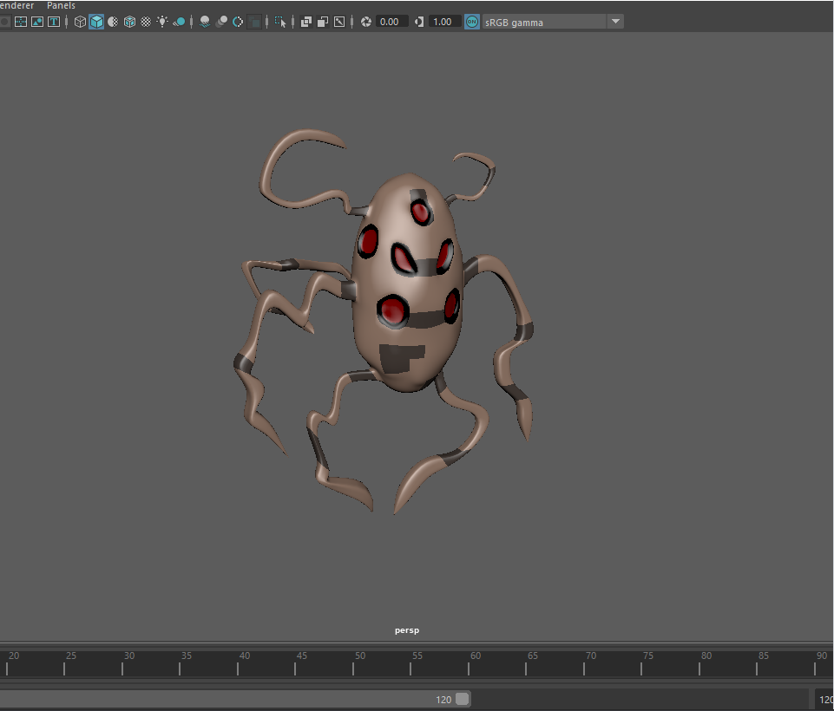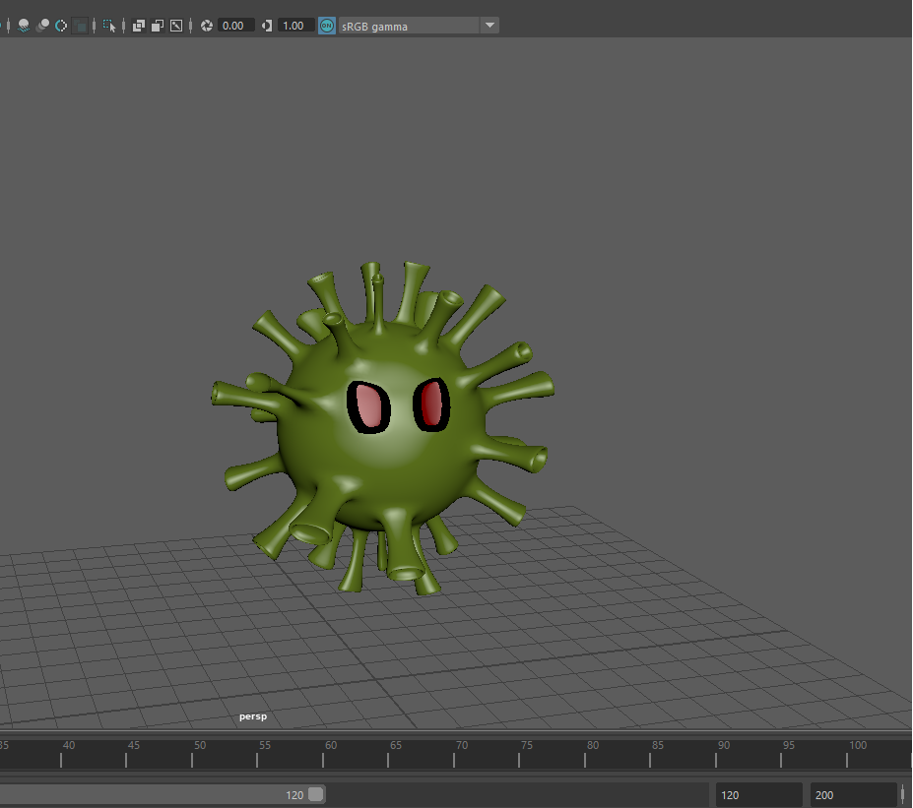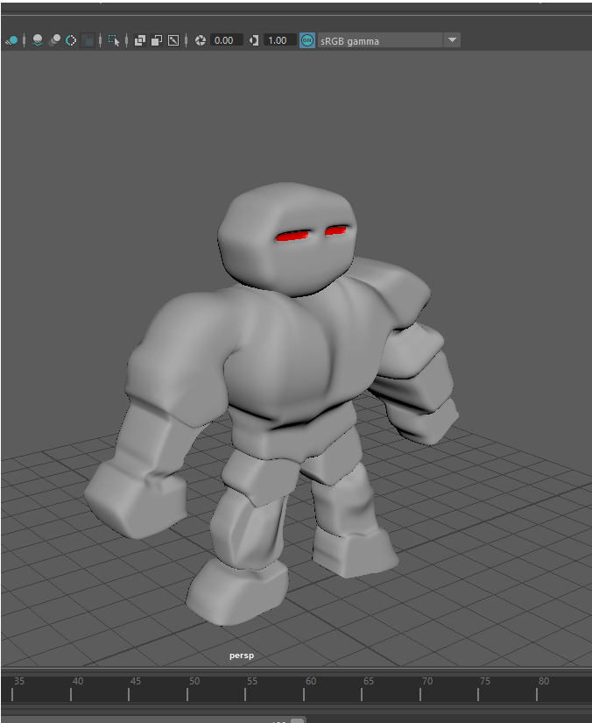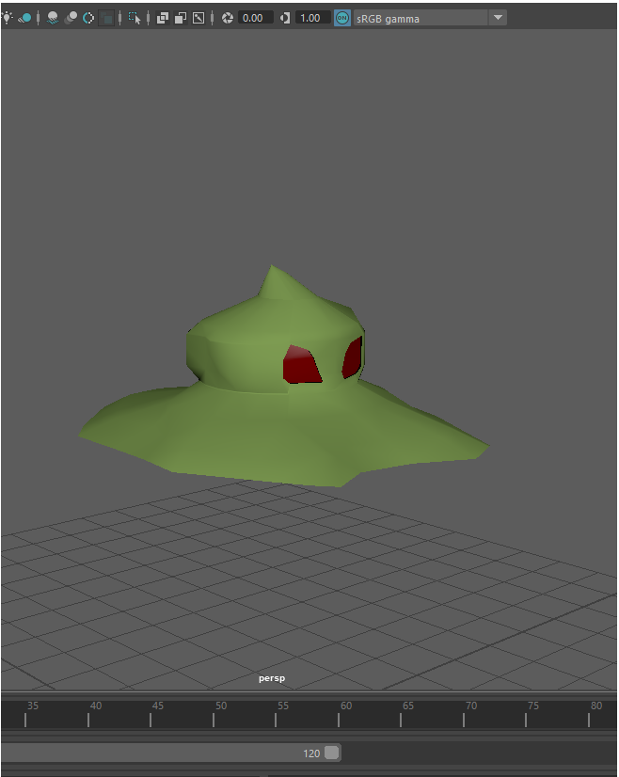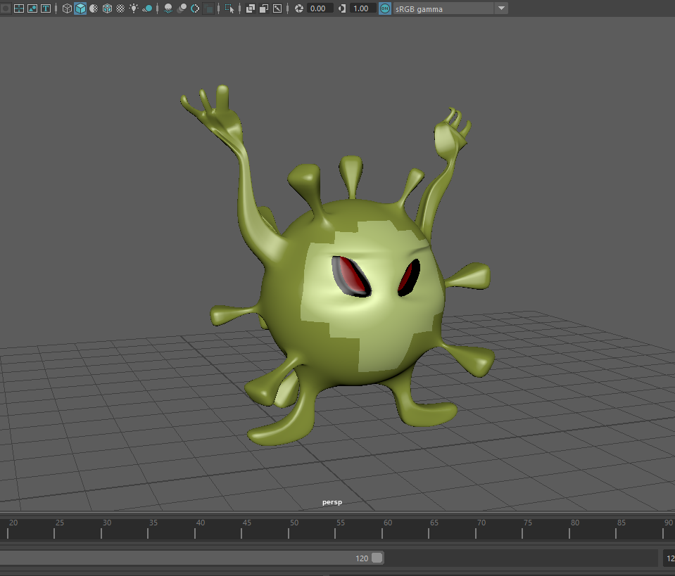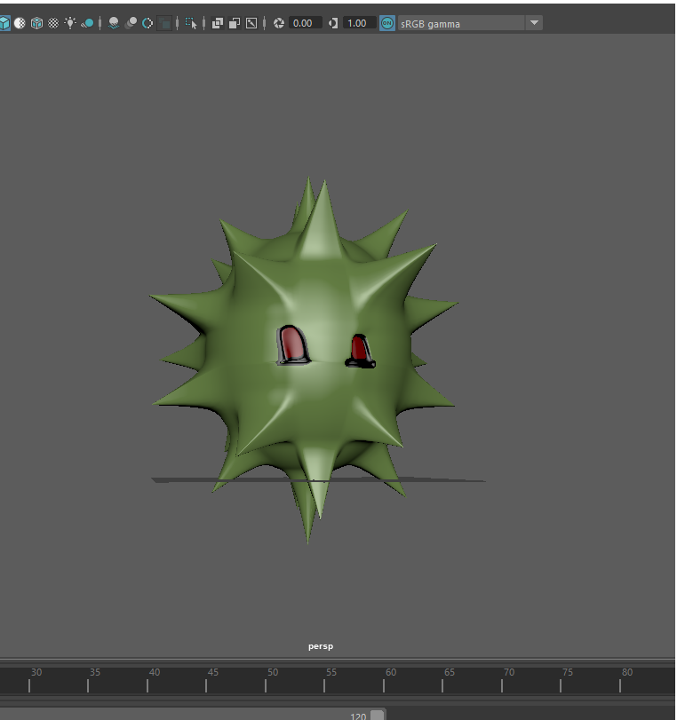

**Player Controller**

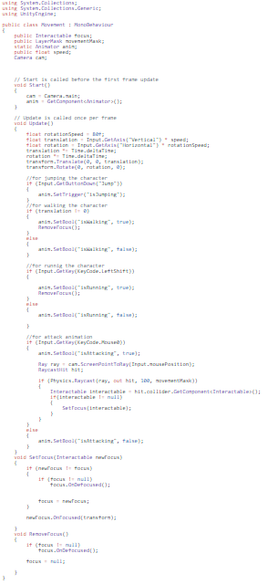

**Enemy Controller**

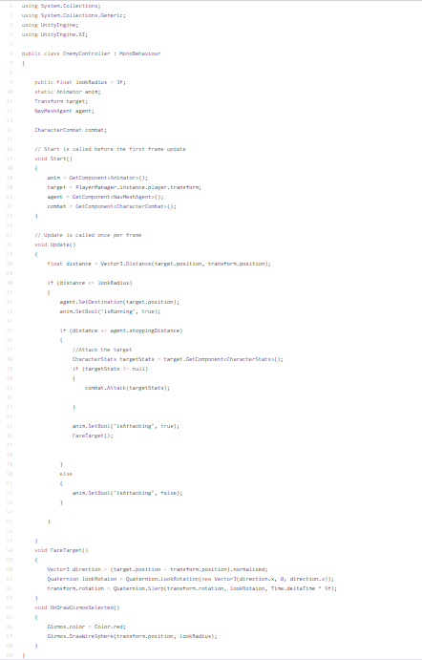

**CHAPTER 4  
SUMMARY AND FINDING**

The Research aim to conduct a game that offers entertainment and challenges to users. The game give a lot of fun and knowledge to the players which is inspired to educational hack and slash adventure medical game and destructible obstacle that hinder the player’s progress and must be attacked until destroyed and give them idea/strategy on how to kill the enemy and survived in the game the researchers aim to give good game mechanics that in line with the story where the game is inspired.

**CONCLUSION**

In today’s generation technology has created amazing tools and resources, putting useful information at our fingertips. Modern technology has paved the way for multi-functional. With all of these revolutions, technology has also made our lives easier, faster, better, and more fun. There are many hack and slash game available in the market but regarding to that, the researchers find ways to innovate a hack and slash game that will make a difference among other hack and slash game The researchers focus on the medical side so that the player will be educated and have fun at the same time and that will make the game more interesting and exciting to play.

The goal of the game is to create a fun medical educational offline hack and slash game. The game will be focusing on the diseases that is given and give tips to prevent and cure them.

The player need to kill the minions and boss in order to proceed to the next stage  
**RECOMMENDATIONS AND FUTURE WORKS**

The Researchers would like to recommend with regards to number of level of the game. The recommendation is to implement additional number of levels and diseases to finish more of minions and boss to kill and more cut scene for the tips and recommendations.

**APPENDICES**

**A. DEVELOPMENT TOOLS**



VISUAL STUDIO

UNITY

<https://unity.com/> <https://visualstudio.microsoft.com/vs/>



<https://www.autodesk.com/> <https://photoshop.com/en>

# **Bibliography**

|  |  |
| --- | --- |
| [1] | "steam," [Online]. Available: https://store.steampowered.com/app/264340/Major_Mayhem/. |
| [2] | "texasheart," [Online]. Available: https://www.texasheart.org/heart-health/heart-information-center/topics/heart-anatomy/. |
| [3] | t. l. o. zelda. [Online]. Available: https://en.wikipedia.org/wiki/The_Legend_of_Zelda. |
| [4] | g. o. war. [Online]. Available: https://en.wikipedia.org/wiki/God_of_War_(2018_video_game). |
| [5] | t. raider. [Online]. Available: https://en.wikipedia.org/wiki/Tomb_Raider. |
| [6] | "amateursurgeon," [Online]. Available: https://amateursurgeon.fandom.com/wiki/Amateur_Surgeon_Wiki. |
| [7] | "steamtwopoint," [Online]. Available: https://store.steampowered.com/app/535930/Two_Point_Hospital/. |
| [8] | "lifesigns," [Online]. Available: https://en.wikipedia.org/wiki/LifeSigns:_Surgical_Unit. |
| [9] | "myocardial ischemia," [Online]. Available: https://www.mayoclinic.org/diseases-conditions/myocardial-ischemia/symptoms-causes/syc-20375417. |
| [10] | "heartfailure," [Online]. Available: https://www.mayoclinic.org/diseases-conditions/heart-failure/symptoms-causes/syc-20373142. |
| [11] | "heartfailure," [Online]. Available: https://www.mayoclinic.org/diseases-conditions/heart-failure/symptoms-causes/syc-20373142. |
| [12] | "UTI," [Online]. Available: https://www.mayoclinic.org/diseases-conditions/urinary-tract-infection/symptoms-causes/syc-20353447. |
| [13] | "UTI," [Online]. Available: https://www.mayoclinic.org/diseases-conditions/urinary-tract-infection/symptoms-causes/syc-20353447. |
| [14] | "kidneystones," [Online]. Available: https://www.mayoclinic.org/diseases-conditions/kidney-stones/symptoms-causes/syc-20355755. |
| [15] | "KidneyStones," [Online]. Available: https://www.mayoclinic.org/diseases-conditions/kidney-stones/symptoms-causes/syc-20355755. |
| [16] | "asthma," [Online]. Available: https://www.mayoclinic.org/diseases-conditions/asthma/symptoms-causes/syc-20369653. |
| [17] | "bronchitis," [Online]. Available: https://www.mayoclinic.org/diseases-conditions/bronchitis/symptoms-causes/syc-20355566. |
| [18] | "pneumonia," [Online]. Available: https://www.mayoclinic.org/diseases-conditions/pneumonia/symptoms-causes/syc-20354204. |
| [19] | "Pneumonia," [Online]. Available: https://www.mayoclinic.org/diseases-conditions/pneumonia/symptoms-causes/syc-20354204. |
| [20] | "Lungs," [Online]. Available: https://en.wikipedia.org/wiki/Kidney. |
| [21] | "Lung," [Online]. Available: https://en.wikipedia.org/wiki/Lung. |
| [22] | "Hollow_knight," [Online]. Available: https://en.wikipedia.org/wiki/Hollow_Knight. |
| [23] | "kidneystone," [Online]. Available: https://www.mayoclinic.org/diseases-conditions/kidney-stones/symptoms-causes/syc-20355755. |
| [24] | "defendyourlife," [Online]. Available: https://aldagames.com/games/defend-your-life/. |
| [25] | "ozzy and drix," [Online]. Available: https://osmosisjones.fandom.com/wiki/Ozzy_%26_Drix_(Video_Game). |